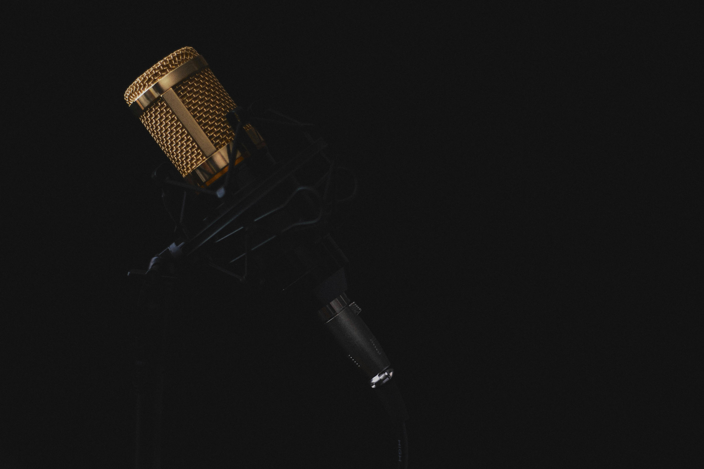
Type to enter text

OPEN MIC NIGHT
AT ALL SOULS UNITARIAN UNIVERSALIST CHURCH
Friday, March 27, 6:30-9:30

Please join us for a Friday night of family fun and social gathering, brought to you be the All Souls Social Activities Committee.

- Open to church members/staff, friends and invited guests.
- Front door will be locked, please use west entrance.
- Admission free (Donations Encouraged).
- Coffee, tea, soft drinks, assorted cookies & treats available (Donations Appreciated). No drinks in the great hall please.
- All monetary donations to go to a specified church project/function as determined by the Social Activities Team.
- We will attempt to split performance times evenly between music, spoken word and other acts.
- Door will be open at 6:00, performances from 6:30 – 9:30.

PERFORMER LIMITATIONS:
Music Performances - no more than 3 songs, no more than 15 minutes
Spoken Word & Other Performances - no more than 10 minutes
No amplifiers
Pre-registration to end Sunday, March 22. Walk ins welcome if time permits. Check in begins at 6 o’clock.
PLEASE NOTE: A meeting of the Social Activities Team will be held March 23 to determine the order of appearance of the acts. A list of the order of appearance will be emailed to each registered contact prior to March 27.

